LA CASA DEL SOL COUNCIL OF CO-OWNERS, INC.
Board Meeting Minutes
Wednesday, October 8, 2025, 1:00 P.M.
18757 S. Highway 377, Cresson, TX 76035
- Call to order at 1:04 pm by Interim President Derrick Richardson on Wednesday, October 8, 2025, with Jamison Drake, Secretary Bill Gunn, Donna Kelly, Mary Baker, and Holly Sparkman via ZOOM. Stuart Weiss was delayed until 1:16 pm. “Welcome Holly!”
- Approval of minutes of previous Board Meeting on 09/17/2025. - Bill Gunn.
  - There being no discussion, Donna Kelly moved to approve those minutes with a second by Derrick Richardson. The approval vote was unanimous.
- Cresson Report & Presentation of Financial Report & Reservation Office. – Mary Baker.
Cash P&L
  - Income – nothing unusual
  - Legal Expense $250.00 to Nueces County for registering deeds
  - M& R Furniture & Appliance $2300.00 to Mike Morphis
    - [no warranties or IRS 1099s supplied by Mr. Morphis]
  - M&R Interior Supplies Laundry Supplies reservation office
Accrual P&L
  - $5065.42 Balance to M&M for wiring, $66.01 for faucet
  - Supplies – Laundry $215.20 final payment Dust Angels, balance is supplies
  - Supplies Cresson - $115.00 reimbursed with Oct rent, office supplies
  - M&R Furniture & Appliance $2300.00 to Mike Morphis,
  - $2370.73 New washer office
Balance Sheet
  - Banks are all reconciled
  - Accounts Receivable - I have a detailed report that matches the totals
  - AP Trade is Lowe’s
  - Credit Card balance paid 10/3
  - 2026 Budget discussion. Submit budget suggestion by Oct. 14, 2025.
  - Baker reported another $20,000 withdrawn from reserves, leaving $52,000.
  - There being no further discussion, Derrick Richardson moved to approve the financial report with a second by Bill Gunn. The approval vote was unanimous.
  - Mary Baker was excused from the next portion of the meeting.
- Interim President Report and Resort Report– Derrick Richardson
  - See the October Resort Reports below for specifics from Derrick Richardson, Jessica Johnson, and Jamison Drake.
  - See the Interim President Report below for additional items from Richardson.
    - Derrick Richardson agreed to assume the role of Interim President and continue his role of VP of Resort Operations until new directors are elected at the Owners’ Meeting and the new board of directors can elect new officers.
  - Interim President Richardson led a thorough discussion on the issue of Conflict of Interest.
    - After a thorough discussion, Derrick moved to have Mary Baker complete the term of Caren Lee as a director, which expires February 28, 2027. Jamison seconded the motion, and the vote was affirmative though not unanimous.
  - After no further discussion, Donna Kelly moved to accept the resort reports with a second by Bill Gunn. The approval vote was unanimous.
- Review of action items
  - Fee increase
    - Derrick moved to table the Maintenance Fee increase discussion until the November meeting, which was seconded by Gunn. The vote was unanimous.
  - Specific rate increases on IP, OSIP, OBT, and Winter Texan are identified below.
    - Each rate was discussed and agreed upon individually
    - Derrick Richardson moved to approve all rates as a package, which was seconded by Jamison Drake. The vote was unanimous.
    - Derrick Richardson moved to activate these rates on November 1, 2025, which was seconded by Jamison Drake. The vote was unanimous.
  - Renting LCDS-owned units
    - Derrick Richardson moved to rent the LCDS-owned unit weeks (i.e., not now deeded to an owner), which was seconded by Stuart Weiss, and the vote was unanimous.
    - Further ground rules on specific guidelines will be identified during future meetings.
    - Holly Sparkman suggested outsourcing all rental promotions, accounting, sales/hotel occupancy tax responsibility, and scheduling through Life in Paradise Management Company, which manages Surfside Condominiums. This would dramatically reduce the pressure on our small Cresson staff.
    - Specific discussions of Rental Options will occur during the November meeting
- New Business
  - 2026 LCDS Budget
    - Holly Sparkman will create forecasting algorithms to better project the needs of operational income and expenses after her upcoming visit to Cresson office.
  - New Bylaws. Discuss and vote.
    - Holly will research LCDS need for an audit.
    - Holly will investigate the LCDS relationship with the Texas Property Code.
    - Derrick moved to table a decision on the bylaws until next month, with a second by Jamison. The vote was unanimous.
  - Nominate and vote new President to fill Jack’s role.
    - Derrick will continue the dual role until the election of new officers after the Owners’ Meeting.
  - Prepare Winter Newsletter to encourage candidates to run for director positions.
    - Bill Gunn is already working on it.
    - [Gunn submitted a first draft after the meeting for approval]
  - Set up annual meeting location and web system. -Mary, Jamison, Holly
    - [Saturday, February 28, 2026, at Comfort Inn in North Arlington]
- Who’s at the resort when?
  - Gunn 10/17 through 10/31
  - Kelly November
- Set date/time for next Board meeting.
  - November 5, 2025, at 1:00 pm
- Before adjournment, Bill Gunn announced he will not seek reelection to the board, which also means he will not continue as LCDS Secretary after the Owners Meeting in February. It also means he can no longer be the LCDS Agent of Record with the Texas Secretary of State. He thanked LCDS and the board for allowing him to be a part of a team dedicated to continuing “our little piece of paradise on North Padre Island.”
- Adjournment.
  - Gunn moved to adjourn the meeting, with a second from Jamison Drake. The vote was unanimous.
  - Interim President Richardson declared the meeting adjourned at 2:25 p.m.
- An Executive Session of the Board of Directors was not needed.

Respectfully submitted,

Bill Gunn, LCDS Secretary

2026 Proposed and Approved LCDS Rates (beginning 11/01/2025)

Owner Bonus Time
One-bedroom units $100 a night
Two-bedroom units $130 a night if available

Interval Plus Weeks
One-bedroom units $400 per week
Two-bedroom units $500 if available

Owner-Sponsored Time
One-bedroom units $500 per week
Two-bedroom units not available

Winter Texan/Snowbird Program
Owners
One-bedroom units $400 a week
Plus $75 cleaning fee
$1600 a month (four consecutive weeks)
Plus $150 cleaning fee
Non-Owners
One-bedroom units $500.00 a week
Plus a $75.00 cleaning fee
$250.00 refundable deposit.
$2000.00 a month (four consecutive weeks)
Plus a $150.00 cleaning fee
$250.00 refundable security deposit.
PRE-MEETING ACTION ITEMS
09/30/2025
Vice-President Derrick Richardson, Secretary Bill Gunn, and Directors Donna Kelly, Stuart Weiss, and Jamison Drake met with Holly Sparkman via ZOOM to discuss her appointment to the LCDS Board to fill the remaining term of Jack Luna. Mary Baker was unavailable for the meeting. After Richardson explained what would be expected of her, Sparkman reviewed her qualifications and experience to fill the role.
Richardson moved to appoint Holly Sparkman to fill the remaining term of LCDS Director Jack Luna (through 2027), and was seconded by Stuart Weiss. The vote was unanimous.
During the meeting, the subject of remote access to the LCDS Cresson Office and QuickBooks was discussed. It is worth noting for board members unfamiliar with QB that Desktop QB can be remotely accessed via the LogMeIn app or the GoToMyPC app, and it features remote printing capabilities. The SplashTop app can also access Desktop QB remotely, but it does not have remote printing capabilities. Discussion of moving to QB Online was tabled for a later discussion as it is not a priority action item.
During the meeting, Gunn pointed out that the LCDS Bylaws require an annual audit of all books and records (Article X Books and Records, Section 10.01, Subsection i). This has not been accomplished in several years. Sparkman pointed out that such action could cost LCDS up to $20,000 to complete. Gunn proposed a rewrite of this subsection to read such an audit every 5 years, instead of annually. Further review, discussion, and approval of the new Bylaws will take place during the 10/08/2025 board meeting.
Sparkman suggested a 30-day hold pending her review of the bylaws and contingency options before taking action.

10/1/2025
Anticipated Role of Holly Sparkman (outlined by Derrick Richardson)
- Work closely with Rachel and Mary.
- Build a relationship with the Cresson Office.
- Assist the Cresson Office with financials.
- Review our operating systems.
- Advise us on operating systems with remote access.
- Provide recommendations in her areas of expertise.
- Taxes, IRS, HOA matters.
- Looked into the rental program and a reservation system pertaining to the rental.’
- Take the lead in the rental program operating system.
- Make physical and virtual visits to the Cresson Office Staff.
- Update the board.
- Selecting an online virtual Meeting System for the annual meeting.
- Look into and advise on cost-saving methods of doing business.

Derrick October Report 2025
Vice President Report
- Mid-year performance evaluations were done on the resort staff and filed in the Cresson Office.
- New Wi-Fi installed. We had a system check a week later. Everything is working better and smoothly.
- Cable boxes will be turned in this month.
- Eventually, we will purchase a new washer.
- Jamison will monitor the TV inventory at the resort.
Interim President Report
- We introduced a new board member. She will take on a needed role in the organization. You have seen the emails outlining the areas she will be jumping in on.
- We will review the insurance policy.
- We will set up the annual meeting
- We will set up a Virtual meeting system. Our concentration going forward is online annual meetings.
- We need to increase rates
- We need to work on the budget.
- New Bylaws. Discuss and vote.
- Nominate and vote on a new President to fill Jack’s role.
- Prepare Winter Newsletter
  - Invite candidates
  - Annual meeting situation
  - Fee increases
  - No more cable
- Bill and Jamison helped Mary find a different internet company for the Cresson Office, not the resort.
- The resort has one cell phone for after-hours and the resort manager. We need to look at replacing the Resort Office landline with a second cell phone to remain in the resort office. The Resort landline is about $145.00 a month. We want a monthly bill automatically to charge to our credit card. Not a pay-as-you-go.
- The Cresson office has one landline. It is more complicated because the checks to the bank and the credit cards go through this line.

Jessica Board Report October 2025

- Purchased washing machine which has been delivered and installed (works great)
- Animal signage has been delivered, and signage has been placed at entry gate and office.
- Purchased wheels for the push carts which have been installed.
- Shed has been completed on B side
- Sheds on both A and B side have been taken apart and disposed of
- Sofa sleepers were taken to goodwill donation location (Jamison along with the guys took them in Jamison’s truck)
- Received exterior electrical bid, total amount for exterior lighting replacement is $7,589.72. Denied by Derrick
- Purchased mulch for landscape which will be laid out week 40/41.
- Half of the property has been completed with power washing buildings.
- Pulling all cable boxes this Friday 10/10 and will be dropping off all equipment to a spectrum location.
- Pending items
- Cut back and remove all dead prawns on tall palms.
- Paint office kitchen area.
- Bids on replacement or repairing lighting.
- Incidents
  - Donald Palmer fell while pushing one of the carts during check in. No medical attention was needed. Incident report was completed and emailed. Checked on Donald every day during his stay.
- Staff continues to work diligently together, making sure all tasks are completed by end of day and or deadline as given.

10/1/2025

Holly’s Cresson Office Visit goals are listed below, please feel free to add/edit. All feedback welcome.

- Intros: Mary, Rachel, Holly
- Overview of current accounting process, procedures, and due dates
- SWOT analysis and staff recommendations for improvements
- Discussion of the separation of duties where achievable
- Outline of expectations for each of us going forward with role, responsibility, and due dates
- 2025 budget overview
- 2026 budget development
- Address the reservation system. -Derrick

Jamison’s Resort Visit Weeks 37 and 38
- A/C compressor change-out for Unit 212 by E.J. Air.
- No hot water in Unit 212 reported to me. Jessica rectified the issue.
- Loaded and dropped off two sofa sleepers at Goodwill Location: In Flower Bluff.
- Hot tub needs leveling, settling on one side.
- Walked with Noe from Island Air regarding exterior vents and condensation in Unit 107.
- I spoke with several renters about opening the resort for rentals, which most agreed to.
- I spoke with several owners about eliminating cable and converting to streaming services. Most owners were in favor of it.
- I spoke with housekeeping about dryer vents and updating the housekeeping checklist.
- I spoke with Martin from M&M regarding the WIFI, which was lagging. He came out and rectified the issue with Jessica Monday, after I checked out Friday, September 26.
- I went over the inventory with Jessica. We went over the linens; we may need to order bathmats and possibly towels.
- I also kept track of the inventory supplies.
- I helped Jessica fold laundry. She showed me how to fold fitted sheets
- Jessica showed me the standard office working procedures and how to do payroll.
- Jessica is doing an exceptional job running the resort. She keeps the staff happy as they all work together.

10/01/2025
Rental rates found by Donna Kelly (see below)

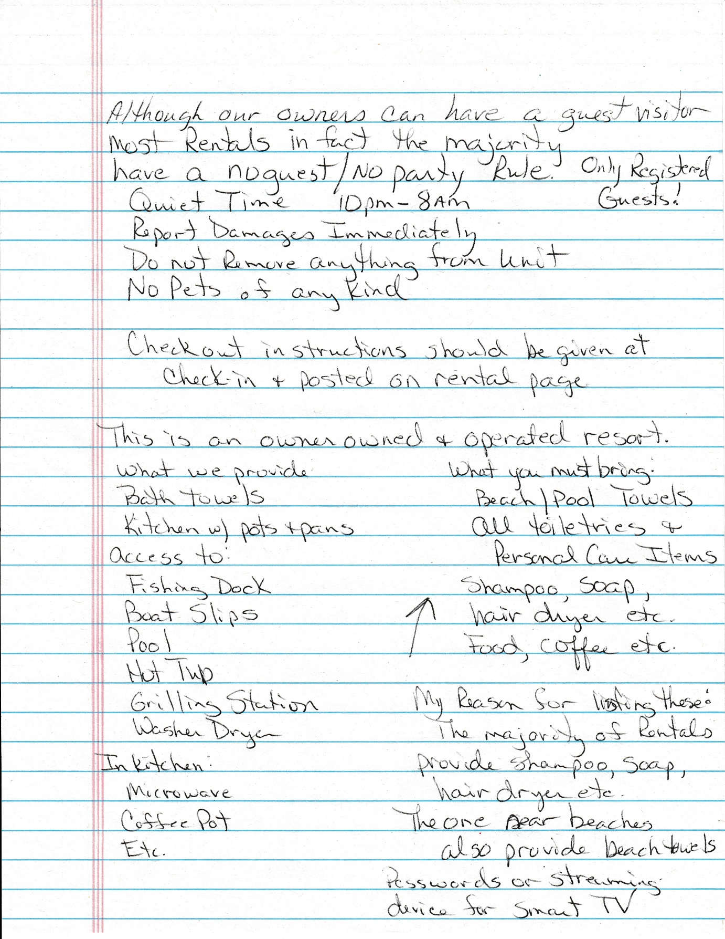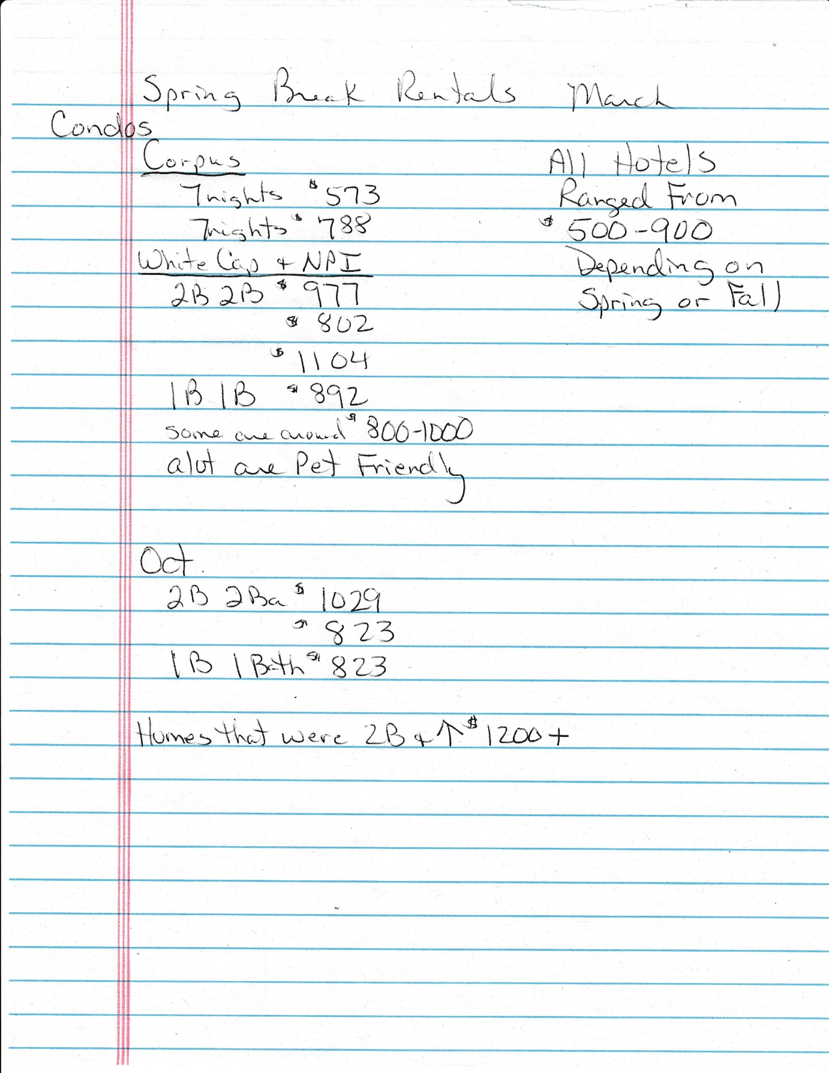

10/01/2025
Rental rates found by Bill Gunn from location websites

LOCATION | 1-BEDROOM 7 NIGHTS | 2-BEDROOM 7 NIGHTS | 3-BEDROOM 7 NIGHTS | POOL | KITCHEN | LOCATED
La Casa del Sol | $800 | $950 |  | yes | yes
Anegada Village | $1,200 | $1,610 |  | yes | yes
Airbnb (several) | $330 - $1100 | $737 - $2860 |  | yes | yes
Anchors Resort | $567 - $ 3101 | $602 - $ 3284 |  | yes | yes
Aruba Bay | $956 - $3795 | $1621 - $ 3795 | $2450 - $4715 | yes | yes
Beach Club | $595 - $1925 | $665 - $1925 |  | yes | yes
Best Little Shore House | 0 | 0 | $2625 - $4620 | yes | yes | Port Aransas
Coles Cabin |  |  | $3,167 | yes | yes | Flour Bluff
El Constante | $805 - $3710 | $1051 - $4466 |  | yes | yes
Emerald Beach Hotel | $833 - $2163 |  |  | yes | NO
Gulfstream Condos |  | $1435 - $ 2590 | $1435 - $ 2595 | yes | yes
Hawthorn Suites, Wyndham | $1,218 |  |  | yes | NO
Holiday Inn Express | $1,353 | $2,710 | $4,100 | yes | NO
Island House | $2220 - $2740 | $2310 - $3070 | $3,738 | yes | yes
Island Villa |  |  | $1,732 | yes | yes
Lively Beach | $1,553
Leeward Bay Townhomes | $791 - $1309 |  | $1092 - $1813 | yes | yes
Leeward Isles | $821 |  |  | yes | yes
Marquesas |  | $1,507 |  | yes | yes
Mayan Princess | $840 - $1670 | $2,475 |  | yes | yes | Mustang Island
Microtell Inn by Wyndham | $553 - $735 |  |  | yes | NO | Aransas Pass
Nautilus Galleria | $752 |  |  | yes | NO
Padre Island Condos |  |  | $1,963 | yes | yes
Pathway to the Sea |  | $840 - $5167 |  | yes | yes
Peaceful Paradise |  |  | $2,489 | yes | yes
Puenta Vista multi-resorts | $1930 - $2316 | $2188 - $2573 |  | yes | yes
Sand Dollar | $264 - $1953 |  |  | yes | yes
Sandy Beach |  | $3,900 |  | yes | yes | Port Aransas
Seashell Collector |  |  | $1,551 | yes | yes
Sunset Harbor |  | $3,346 |  | yes | yes
Sunset View on Canal |  | $1,427 |  | yes | yes
Surfside Condos | 0 | $700 - $2200 |  | yes | yes
Toes in the Water |  | $1,910 |  | yes | yes
Trade Winds | $1,190 |  |  | yes | yes
Vacay at the Beach | $1,859 |  |  | yes | yes
Village by the Beach | $700 - $2100 | $945 - $2856 |  | yes | yes
Wyndham North Padre | $1,022 |  |  | yes | NO
AVERAGE COST for nights 7 | $1,475

